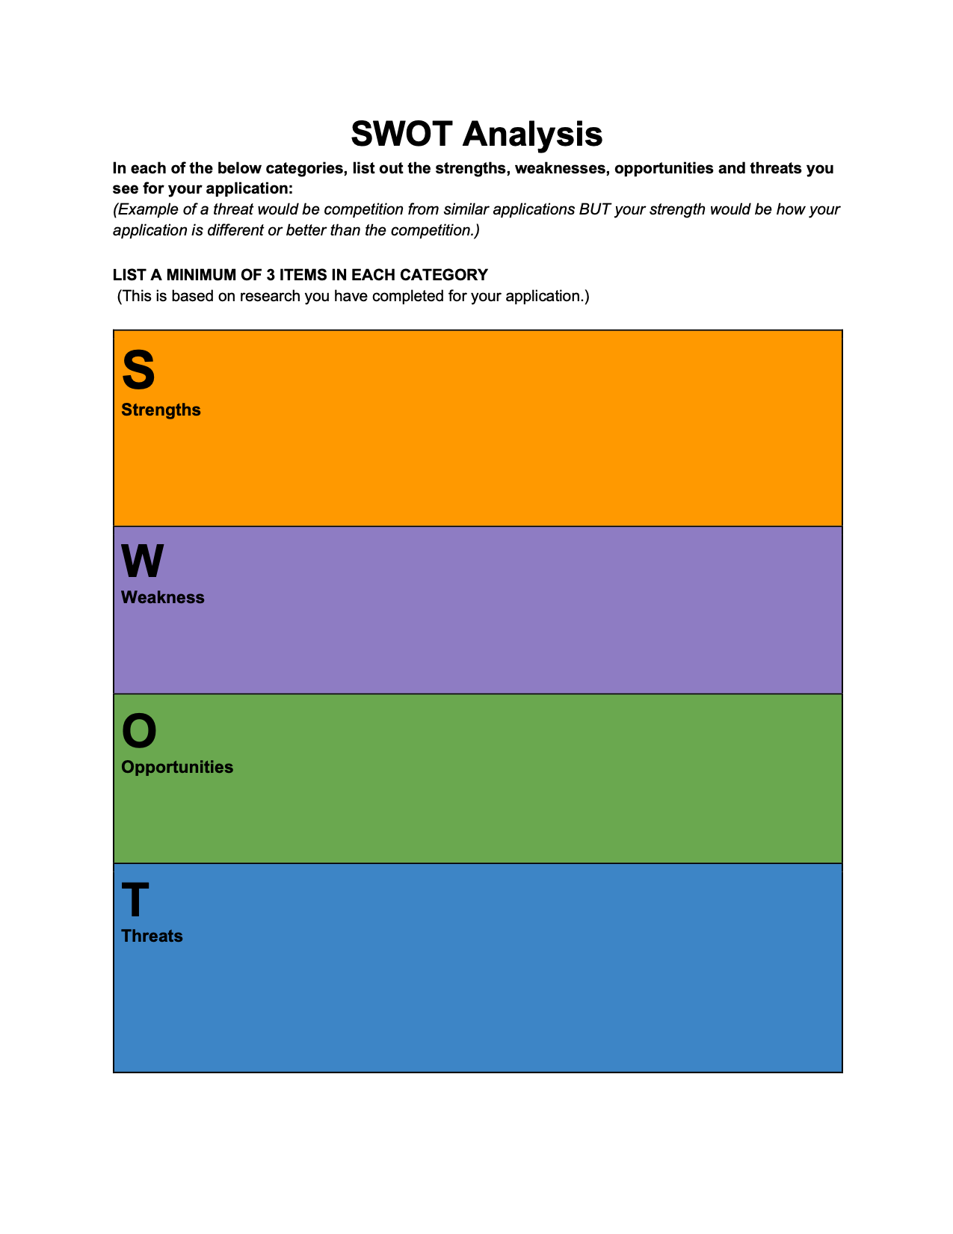

Type to enter text

1. Unique Idea, not alot of other applications
2. Simple concept, easy to understand
3. Solves a big problem.
4. Has potential to build upon.
5. For a niche market.
6. Doesn’t work without a wide user base.
7. No other applications really like it. Nothing to compare to.

1.Traditional hiring methods

2. Websites like [fiverr.com](http://fiverr.com) that offer freelance service.

3. No adoption from users so no database can be built.

1. Create a wide network for Gym owners and trainers.
2. Provide unique profile for both to establish reputation
3. Start a new style of hiring for this business model.